CHIPPENHAM & DISTRICT WHEELERS

This event is being promoted for and on behalf of Cycling Time Trials under their Rules and Regulations.

OPEN HILL CLIMB - UHC80 – Bowden Hill Lacock

Saturday 03th October 2020. Time of start – 10:00 hours

In the interests of your own safety, Cycling Time Trials and the event promoters strongly advise you to wear a HARD SHELL HELMET that meets an internationally accepted safety standard. Riders signing the entry form state their conversance with Cycling Time Trials Rules and Regulations and agree to observe them.

EVENT OFFICIALS
Event Secretary
Ian Potts Chippenham & District Wheelers
19 Garth close
Chippenham
SN14 6XF
07891 138269 (mobile)

Timekeepers
Start: Andy Greatwood
Finish: Mrs Sue Andrews Chippenham & District Wheelers

Officials
Start: Mr Rob Gough Chippenham & District Wheelers
Finish: Mr Andy Cook Chippenham & District Wheelers

EVENT HQ: Organisers: Mr Ian Potts & Mr Paul Freegard
My thanks to all the volunteers in addition to the officials:
David Hearne – Chippenham Wheelers
Simon Giddings
Jeremy Tyzack – Chippenham Wheelers
Event HQ: Red Lion Carpark, Lacock, Wiltshire, SN15 2LQ
- Refreshments – due to COVID restrictions there will be no refreshments
- Toilets public in car park – please use one at a time
- Numbers and Signing On – please use your own pen
- Prize Presentation – prizes will be sent after the event to winners
- There are no changing facilities at the Event HQ, so please change considerately
- Event HQ should be open from 09.00 hrs
- all riders are asked to depart as soon as they can once finished, which is in line with COVID restrictions at the moment in any case.

There is a some parking at the HQ aslo limited in the high street and a large national trust car park around the corner please park considerately and not block drive ways.

NOTICES: (Due to COVID the notices are longer than usual but please do read them)
IF YOU ARE SHOWING ANY SIGNS OF COVID 19 PLEASE DO NOT COME TO THE EVENT

- This event is run under CTT regulations which can be found here: https://www.cyclingtimetrials.org.uk/
- Please ensure you have read the CTT COVID-19 guidelines at https://www.cyclingtimetrials.org.uk/documents/index/covid-19
- You are asked to not urinate in the carpark or grounds or change in full view of any of the residents. We are very lucky to have this facility, so please do not give them reason to take it away. All future references to “HQ” in this document are referring to this facility. DO NOT arrive too early or you will be asked to stay in your vehicle. There will be no gatherings permitted in the carpark.
- Turbo trainer/roller warm up are permitted at HQ but only directly behind/infront of your parked vehicle. You are encouraged to warm up on the road to ensure you are not gathering with other riders. Riders not following guidelines or instructions from officials will not be permitted to race and may be reported to CTT.
- Sign-on is currently very different to what we are used to. No hugging, no kissing and no exchanging of niceties. But there are some other restrictions in place. You will be expected to follow them. Please bring your own pen! We will ask you to respect the social distancing rules and maintain 2m distance between people in all directions at all times. This is to ensure we can successfully run this event and others in the future and that any curtain twitchers have no material to send to the local gossip column/social media outlet/news outlet. We are all in this together so please respect the volunteer team and their decisions. Riders not adhering to the restrictions in place will not be permitted to race, may be reported to CTT and may be refused entry to future events.
- Your number will be placed on a table at the HQ, please check your number on the list below. The numbers have not been used this year and the person putting them out will have taken necessary sanitizing steps before and after laying them out.
- CTT requires all riders to sign out of events when finished. Failure to complete the signing out sheet will result in the rider being disqualified. Other riders or individuals must not sign out for other people.
- Please hand your number in when signing out. We have had several go missing recently and they are expensive to replace.
- . A working rear light, either flashing or constant, must be fitted to the machine in a position visible to following road users and is active whilst the machine is in use
- Please respect the volunteers from Chippenham and District Wheelers and the timekeepers who are giving up their time to help out.
- Position your main number so that it is visible from the rear when in the racing position.
- This event may be subject to a Doping Control - It is your responsibility to check by returning to the HQ and signing in as soon as possible after you finish.
- Please allow at least 10 minutes to get to the start.
- Head-down riding kills – if dangerous riding is witnessed it will be investigated and reported.
- No vehicles, except those of the timekeepers, shall be parked at the start or finish
- IN THE INTERESTS OF YOUR OWN SAFETY Cycling Time Trials and the event promoters strongly advise you to wear a HARD SHELL HELMET that meets an internationally accepted safety standard. In accordance with Regulation 15 ALL JUNIOR competitors must wear Protective Hard Shell Helmets

The Time Keepers will be wearing face coverings and will be checking that riders a) have their number attached and, b) have a working rear light. If either of these are missing you will not be permitted to race. There will be no “pusher offer” and you will have to do a standing start on your own. Rolling starts will not be permitted. Make it easy for the finish time keepers, when you cross the line, shout your number. As loud as you can. Do not approach the finish time keeper at any point for any reason. Once you have finished your race return to HQ to sign out

Race Results will be published on the CTT website as soon as possible.

Start List Appendix A is the rider list with the number assigned to you. This is the number that must be collected from the HQ upon arrival. Please do not swap numbers: your emergency contact details are assigned to this number and we really don’t want to be phoning the wrong person in case of an emergency. If you are unable to attend, DO NOT swap your name with someone else. Riders found doing this will not be permitted to race, will be reported to the CTT and may not be accepted in future events.

Vehicles on course Time trialling under CTT regulations is unsupported. Riders must not be followed for any reason whilst on course. Any rider suspected of this will be disqualified and reported to the CTT. This practice and so called layby hopping is dangerous for other participants and a nuisance to traffic and will not be permitted under any circumstances.

Summary In these unusual circumstances we find ourselves having to change the way we run events. The team has put a lot of work into making sure we are able to follow the government guidelines, the CTT guidance and make sure that the risk to you, us and the general public of transmitting or catching COVID-19 are kept to an absolute minimum. These restrictions are not here to make life difficult for you or the volunteer team, they are here for the above reasons but also to ensure that we are allowed to run these events. We would like to thank all our volunteers and hope that you enjoy the event

Ride Safe. Ride Strong. Thank you for your support!

COURSE DETAILS

To reach start from event HQ turn right and proceed up the hill to the start o
- LIMIT U TURNS TO AN ABSOLUTE MINIMUM AND QUEUE TO START IN SINGLE FILE IN LAYBY. DO NOT QUEUE ON THE ROAD.
- PLEASE DO NOT WARM UP PAST THE START AREA.

START: Start after the river before Bewley lane.

https://ridewithgps.com/trips/12663072

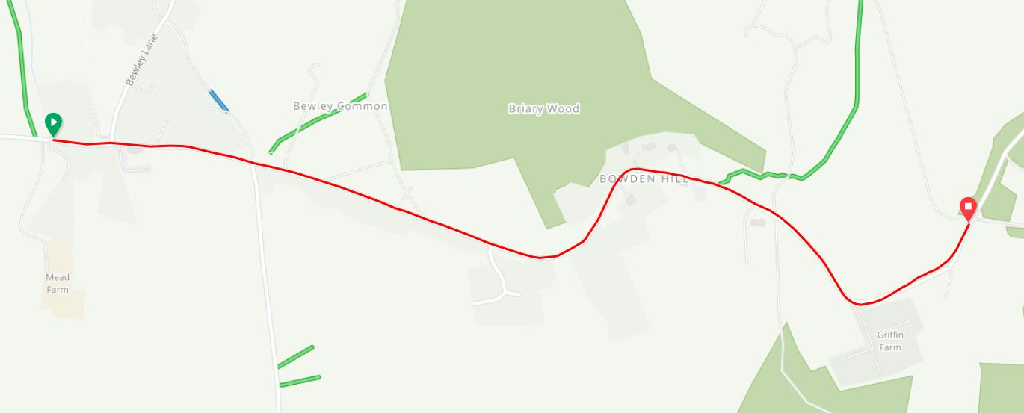DO NOT STOP on finishing, but warm down and return to HQ.

PRIZE VALUES
Overall |  | Vets |  | Others
1st Place | £25.00 | 1st Place Vet Overall | £20.00 | 1st Place Lady | £25.00
2nd Place | £20.00 | 2nd Place Vet Overall | £10.00 | 2nd Place lady | £20.00
3rd Place | £15.00 | 1st Jr | £10.00
One prize per rider (except team). In the event of a multiple claim the greater value prize will be awarded.
Prizes will be forwarded to riders after the event.
ORDER OF START
start_time | number | firstname | lastname | club | Cat
10:06 | 6 | David | English | Chippenham & District Wheelers | V4
10:07 | 7 | Elizabeth | Sanders | Avid Sport | Lady
10:08 | 8 | Steve | Thomas | Bristol Road Club | V5
10:09 | 9 | William | Jewitt | JRC Shutt Ridley RT | Junior
10:10 | 10 | B Xavier | Disley | AeroCoach | Senior
10:11 | 11 | Harvey | Thomas | Bristol Road Club | Juvenile
10:12 | 12 | Edward | Arnold | Stroud Valley Velos | Senior
10:13 | 13 | Francesca | Derry-Evans | Rogue Racing | Senior
10:14 | 14 | Lawrence | Martindale | Chippenham & District Wheelers | Junior
10:15 | 15 | Oscar | Hutchings | Team Tor 2000 | KALAS | Senior
10:16 | 16 | James | Gill | 360VRT | Senior
10:17 | 17 | Harry | Chamberlain | Bynea Cycling Club | Senior
10:18 | 18 | Tejvan | Pettinger | Sri Chinmoy Cycling Team | V4
10:19 | 19 | Frazier | Carr | SPIRIT TIFOSI RT | Senior
10:20 | 20 | Bexy | Dew | Army Cycling | Senior
10:21 | 21 | Ben | Watkinson | Audax UK | Senior
10:22 | 22 | Richard | Bennett | Bristol South Cycling Club | Senior
10:23 | 23 | Neil | Duffin | Wiltshire Police Cycling Team | Senior
10:24 | 24 | Charlie | Bird | Rogue Racing | Senior
10:25 | 25 | Carl | Jolly | University of Bristol Cycling Club (UOBCC) | Espoir
10:26 | 26 | Connah | Towers | Army Cycling | Senior
10:27 | 27 | Andrew | Metherell | Salt and Sham Cycle Club | V4
10:28 | 28 | Jerry | Rayner | Westbury Wheelers | V4
10:29 | 29 | Madeleine | Heywood | Lea Valley CC | Lady
10:30 | 30 | Nicole | Coates | Torelli | Lady
10:31 | 31 | Richard | Emery | Severn Road Club | V5
10:32 | 32 | James | Bevan | Army Cycling | Senior
10:33 | 33 | Helen | Gray | Rogue Racing | Lady
10:34 | 34 | Thomas | Hall | Bristol South Cycling Club | Senior
10:35 | 35 | Danny | Lake | 360VRT | V4
10:36 | 36 | Paul | Haynes | A2B Cycle Repair Race Team | V4
10:37 | 37 | Matt | Melville | Cycle Club Basingstoke | V4
10:38 | 38 | Tavis | Walker | Rogue Racing | V4
10:39 | 39 | Charlie | Lacaille | University of Bristol Cycling Club (UOBCC) | Espoir
10:40 | 40 | Jacques | Coates | Team PB Performance | Espoir
10:41 | 41 | Sasha | Smith | FTP (Fulfil The Potential) Racing | Lady
10:42 | 42 | Matthew | Britton | Avid Sport | Junior
10:43 | 43 | Stuart | Welch | Wiltshire Police Cycling Team | Senior
10:44 | 44 | Jon | Wiggins | PDQ Cycle Coaching | Senior
10:45 | 45 | Ellie | Wallbaum | Avid Sport | Lady
10:46 | 46 | Paul | Winchcombe | Chippenham & District Wheelers | V6
10:47 | 47 | Vivienne | Tomlin | CC London | Lady
10:48 | 48 | Nicole | Corin | Rogue Racing | Lady
10:49 | 49 | Ellie | Mitchinson | CC Ashwell | Lady
10:50 | 50 | Glyndwr | Griffiths | 73 Degrees Bicycles, WestSide Coaching rt | V4
10:51 | 51 | Corinne | Clark | FTP (Fulfil The Potential) Racing | Lady
10:52 | 52 | Luke | Browne | BS10 Cycling Club | Senior
10:53 | 53 | Wayne | Williams | Sodbury Cycle Sport | Senior
10:54 | 54 | Tom | Williams | Webbs 1902 CC | Junior
10:55 | 55 | Jonathan | Morris | AeroCoach | Senior
10:56 | 56 | Sam | Westlake | PDQ Cycle Coaching | Senior
10:57 | 57 | Jessica | Rhodes-Jones | AeroCoach | Senior
10:58 | 58 | Marc | Allen | Swindon Road Club | V5
10:59 | 59 | Dave | Mitchinson | CC Ashwell | V4
11:00 | 60 | Richard | Gildea | Didcot Phoenix CC | Senior

Please note your name is on the start sheet as it appears in the CTT Database. You can edit your name to make in upper and lower case.

